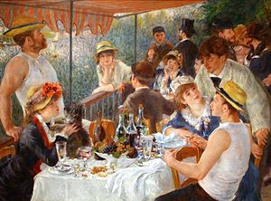

Renoir’s Luncheon of the Boating Party (1881)

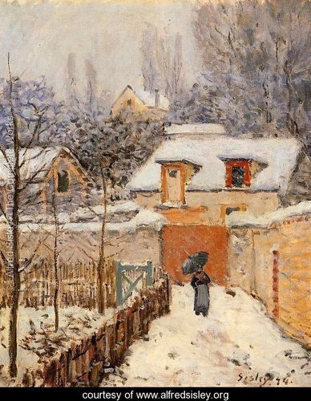

Sisley’s Snow at Louveciennes) (1875)

Design Principles
Music | Painting
Density:  Sounds & Silence | Spaces:  Positive and Negative
Contrast of  Aural Elements | Contrast of  Visual Elements
Climax & Release | Focus & Perspective
Proportion & Size | Proportion & Size
Overall Feeling Evoked | Overall Feeling Evoked

Design Elements
Music | Painting
Melody | Line
Form | Shape
Timbre | Color
Musical harmony of pitches | Visual harmony of colors
Dynamics (loudness) | Intensities of colors
Aural rhythm | Visual rhythm
Textures of sound thickness | Textures of brush strokes

Debussy
des pas sur la neige
France
1910
Joplin
New Rag
New York
1912

